**Title: Post-Processing**

**1.0 Purpose**

To take an image and make it look like an oil painting.

**2.0 Method/Results**

For each pixel I had to calculate the intensity of the sub pixels, and determine which bin the number falls into. I then had to maintain a count for how many sub-pixels fall into each bin and the total RGB values for each bin too, these will come together to determine the final value of the pixel;

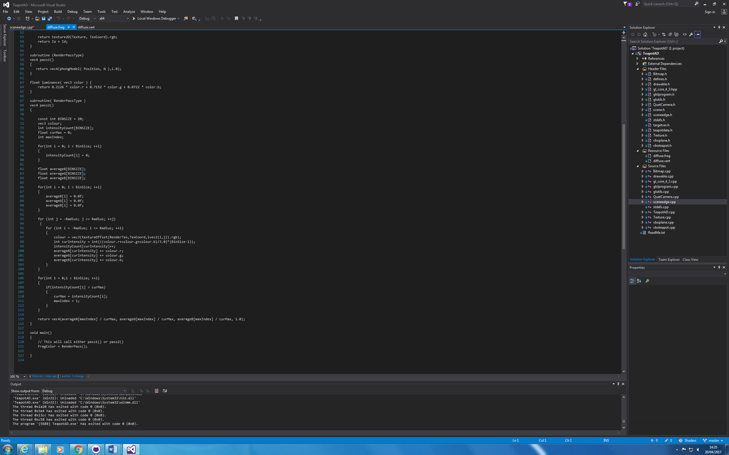

After I calculated that in the fragment shader, I then moved onto determining which bin has the most number of pixels in it, this is shown above also.

I moved onto getting the final colour of the pixel by taking in the RGB values and dividing by the total number of pixel sin the bin;

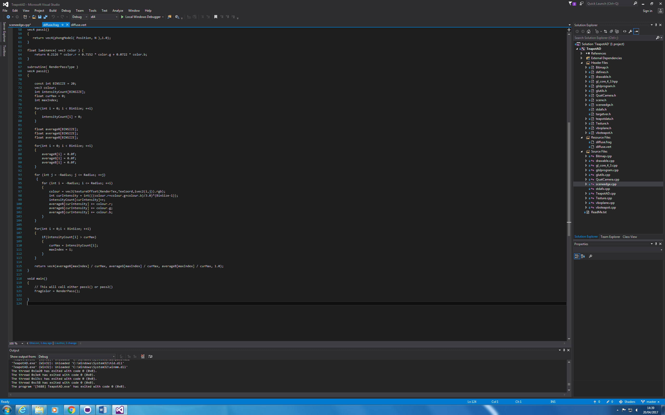

**3.0 Comments/Conclusion**

